What’s New with VRLA Catalysts?
By Harold A. Vanasse, Philadelphia Scientific

It has been almost 100 years since Thomas Edison first used a catalyst in a flooded cell to recombine the battery gases into water and almost four years since Philadelphia Scientific first commercialized its original catalyst design. What could have happened in the last four years to warrant an article in Batteries International? The answer is a lot. This old technology with a brand new application has more potential than ever and with some recent discoveries about the chemistry of VRLA cells, a new design, a new patent, and new areas to apply the benefits of an internal catalyst, it is as exciting a technology as ever.

For those not familiar with catalysts for VRLA cells here is a summary. (For more detailed information about this subject, please refer to our website at www.PhiladelphiaScientific.com). In the past, we have found that a catalyst can benefit a cell by compensating for impurity-based negative plate self-discharge and by reducing float current.

It has been repeatedly shown that the installation of a catalyst into a VRLA cell can correct the imbalance in the chemical reactions caused by impurities in the active material. This imbalance leads the negative plate to self-discharge over time. The balancing action of the catalyst will eliminate the problems of negative plate self discharge, namely the reduction of cell capacity and cell life. An additional benefit of the catalyst is that it will also compensate for small air leaks in the cell that would otherwise harm it.

In a cell with healthy negative plate polarization, the installation of a catalyst causes the float current to dramatically decline to about half that of a non-catalyst cell. This important result applies to both pure and impure cells equipped with a catalyst. The reduction in float current translates into a reduction in cell heating, the minimization of cell water loss, and in the long run, into longer life and better performance. With the additional benefits of a lowered risk of thermal runaway, direct energy savings due to reduced float current (and reduced air conditioning costs), you have numerous reasons to use a catalyst.

The table below outlines the benefits to date, but there are more to come:

Benefits of Reduced Float Current | - Increased Life  - Minimized Water Loss  - Minimized Positive Plate Corrosion  - Reduced Cell Heating  - Reduced Risk of Thermal Runaway  - Direct Energy Savings

A very visible sign that the catalyst is working, and that the negative plate is polarized, is the reduction of the float current within hours of installation. This float current reduction will be maintained as long as the catalyst remains in the cell and is functional. This is illustrated in Figure 1, which shows a long-term test of VRLA cells with and without catalysts. These cells have been on float service at 2.27 volts per cell and at 32°C (90°F) for the life of the test. This test has been running in our lab for more than 5 years and the results have been remarkably consistent over time.

Float current reduction is especially significant for VRLA cells used in high temperature applications. Initial results indicate that at 40°C (100°F), the catalyst cell’s float current was lower by half or more than that of the control cells. As expected, water loss in the catalyst-equipped cells was also significantly lower.

While what I have already written about is still exciting, it is not new and others have reported it on at length. This article is supposed to be about what is new in the world of VRLA catalysts. Let’s start off with the shocking discoveries we have made about the environment of a VRLA cell that could be deadly to precious metal catalysts.

The results of some of our long term testing gave us reason to be concerned about the battery environment’s effect on the catalyst. Our product has been in service for four years and we have seen some isolated instances of catalyst deactivation. In our efforts to discover what happened, we were led into an investigation of battery chemistry.

Our tests led us to discover that there is a reaction between the negative plate and sulfuric acid that produces hydrogen sulfide (H₂S); this reaction is unknown in the battery industry. This was a concern because hydrogen sulfide is a known poison to precious metal catalysts.

After extensive testing, we showed that the generation of H₂S was independent of voltage (polarization). We also found that the concentration of H₂S in the evolved oxy-hydrogen gas was extremely high, varying between 300 and 600 ppm. This was very surprising because, at this concentration, we would have expected an overwhelming smell of rotten eggs in every VRLA battery room in the world, but this is not the case.

Upon further investigation we recognized that the lead dioxide of the positive plate is a tremendous absorber of H₂S. This material is mopping up much of the H₂S produced in the cell. So now we have two new reactions to consider in the cell: one that makes H₂S, and another one that absorbs it.

The relationship between the two reactions was the next area we investigated. We theorized that under normal operation, the resulting equilibrium level of H₂S in the gas emitted from the cell would have a concentration lower - probably significantly lower - than 1 ppm. We confirmed this by using a gas chromatograph to sample a variety of VRLA cells from several manufacturers.

One question that remained was how did this reconcile with the reported cases of very high H₂S generated in thermal runaway situations? It has been widely reported that copper connections have been blackened by H₂S in battery rooms where cells have gone into thermal runaway. Our conclusion was that the higher current of a cell in thermal runaway would produce a large volume of gas and that this large volume of gas would overwhelm the H₂S absorption capacity of the positive plate. Subsequently gas with a high concentration of H₂S would be released from the cell. So what was not noticeable under normal float conditions became very noticeable in thermal runaway situations because the absorption capacity of the positive was surpassed.

The H₂S formation and absorption processes just described became the basis of a preliminary working theory. It also became the foundation of a paper that I co-authored with Frank Vaccaro and Volen Nikolov that will be presented at the Intelec 2001 Conference this year. We know that we have just scratched the surface on this subject and that there are many more unanswered questions, such as: Do different VRLA manufacturers have very different H₂S levels? Does the level of H₂S change over time? Does the level change by application? Does the wetness of a cell affect the concentration? Do the different phases of charge result in different levels of H₂S? How does the purity of materials affect the level of H₂S?

We have started to address some of these questions. Our latest testing has given us reason to believe that the production of H₂S in a cell decreases over time. Our current theory is that the high concentration of H₂S is produced by a precursor sulfur species in the acid and that the depletion of this species over time causes the noticed reduction. As of the writing of this paper, we do not know what the exact precursor elements are. We are hopeful that the battery manufacturers will conduct their own research into this area and discover some of the answers to these questions.

Closer to home and more immediate, one of the outcomes of this investigation was that it drove us to advance the design of our catalyst product by developing a poison-protected design that we are now commercializing. Armed with the knowledge that we were dealing with H₂S, our task was to develop a new catalyst design that would survive such an environment. It is commonly known that battery gases such as stibine and arsine poison precious metal catalysts. Unfortunately, activated carbon, the standard filter solution for these gases is not effective against H₂S. Our design goal then became incorporation of an effective H₂S filter into our product. Our research led us to a very effective material that, when impregnated on activated carbon, produces a dual-acting filter that is capable of protecting a precious metal catalyst from the traditional poisons in addition to our newly discovered one.

One of the constraints on our new design was that we had to force all of the incoming gas to pass through the filter layer. Our previous design was open to gas flow on all sides, but on this design we limited the opening to one end only. By controlling the gas flow in this manner, we gained the ability to limit the amount of gas entering the catalyst and therefore to control the amount of recombination that the catalyst could perform. This meant that we could now control the maximum temperature produced by the recombination reaction of the catalyst.

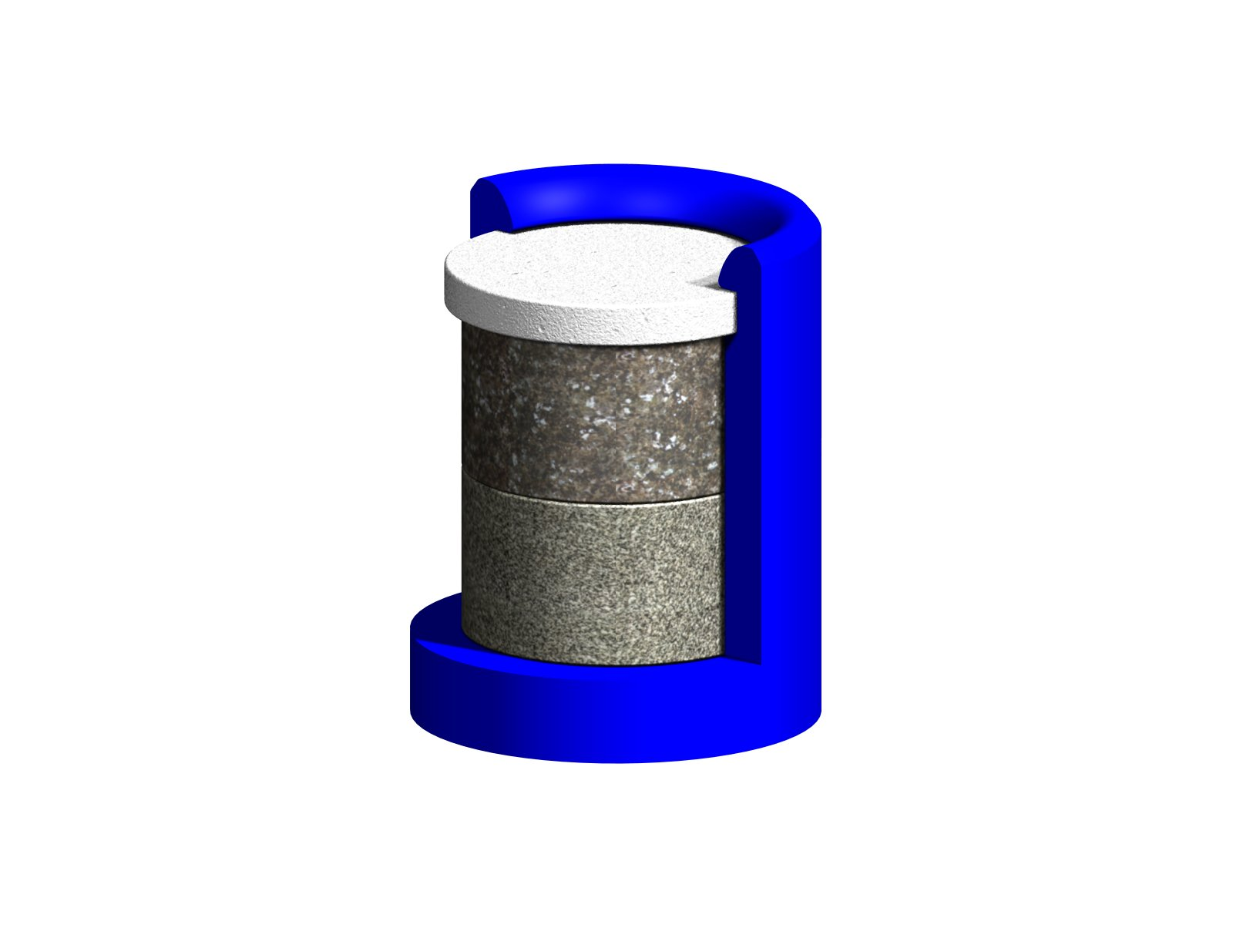
Once we had identified all of the constraints, the design came together into a relatively simple device, which we called the Microcat™. The design has further patents pending and has been recently adopted for use by a major battery manufacturer. The Microcat™ relies on placing the filter material in advance of the catalyst material in the gas stream. This basic “guard layer” approach is a common method to pre-filter poisons from a gas stream. The other main elements that we incorporated into the new design include a high temperature plastic housing, a layer of precious metal catalyst and a microporous hydrophobic membrane.

The Microcat™ is attached to a vent cap and sits in the headspace of the cell. Gas enters the Microcat™ through the membrane, passes through the filter layer and then recombines on the surface of the catalyst. H₂S is stripped away from the gas stream by the filter material and is rendered safe for the catalyst. Water vapor passes back into the cell in the reverse direction. By limiting the amount of gas that can diffuse into the Microcat™ through the membrane, we control the reaction rate and thus the maximum temperature that the unit can reach. We have engineered the Microcat™ not to exceed 65°C (150°F) or one amp’s worth of gas recombination (11.4 ml/min). At a rating of 1 amp, the Microcat™ has more than enough recombination capability to do its job. The Microcat is used in conjunction with the oxygen cycle and therefore only needs to recombine a fraction of the gas produced by the cell.

The question that still remains, however, is how long this new catalyst design will last in the presence of H₂S? This is hard to answer since we do not know exactly how much H₂S a given cell will produce and whether this varies by manufacturer. Our own estimates suggest that with a filter, our Microcat life will exceed the needs of users of VRLA cells. We continue to work on a more quantitative answer.

Two years ago, we demonstrated conclusively that VRLA cells with less than pure active materials self-discharged on float. Water loss and reduction of life at high temperature were also related problems. Catalysts installed into the headspace of these cells will correct these serious problems. But even with the most pure cells (and their lower self discharge rates), the catalyst has value because it reduces the float current approximately by half. In other words, a very pure cell could be made even better, from an energy use and water loss prevention perspective, by the installation of a Microcat™. In today’s world of the ever-increasing use of recycled lead, cells made of very pure materials will be harder to produce. The need for catalysts to compensate for the use of less pure materials will become more important.

The reduction of float current takes on even more importance in high temperature applications, where any possible source of heat minimization and water loss reduction is valued. A reduction of a cell’s float current by one half, would also result in the direct reduction of the cell’s own internal heat production. We envision high temperature applications where VRLA cells that suffer from dry out and positive grid corrosion (also current dependent) are greatly benefited by the addition of a Microcat™ due to the decrease in current. Monobloc batteries and larger 2 Volt cells both being the immediate natural candidates.

Another exciting application for the Microcat is cycling VRLA cells. These cells lose water due to the need for high voltages during the finishing stage of charge. In this application, the catalyst reduces water loss. More importantly, it also protects the negative plate from self-discharge during cycling applications. In one test carried out by a battery manufacturer, a tubular cell without a catalyst died after 1100 cycles (80% DOD). When a catalyst was placed into this cell, the capacity recovered and continued until the test was cancelled approaching 1700 cycles. The reason for the initial cell failure was clearly negative plate self discharge, which was overcome by the installation of the catalyst.

Further evidence of the new life still left in this old technology is our very recent awarding of a patent for the general use of catalysts in VRLA cells. Even though there are numerous patents surrounding the use of catalysts in batteries for water loss reduction, Edison’s original goes back almost 100 years; Philadelphia Scientific’s specifically covers catalysts used in VRLA cells. For us it came as the culmination of many years of research and development and was independent proof that there was still plenty of room left to innovate in this area of battery product development. But it does not end with the patent. There are still many questions to answer about hydrogen sulfide and there are still many more cells in the world without catalysts than with them. We also have more applications to explore and work to do to convince those that aren’t currently using catalysts that they are missing out on a variety of benefits.

I started out this article with the question of whether the sun has set on this old/new again technology. The fate of the catalyst is tied in with the fate of VRLA technology in general. We believe that the latter will be a better and more robust product because of the first. Mark Twain’s oft quoted phrase “The report of my death has been greatly exaggerated” seems apropos in the case of VRLA and we believe that this is in part due to a new application of an idea that originated around the same time Mark Twain made his famous statement.

